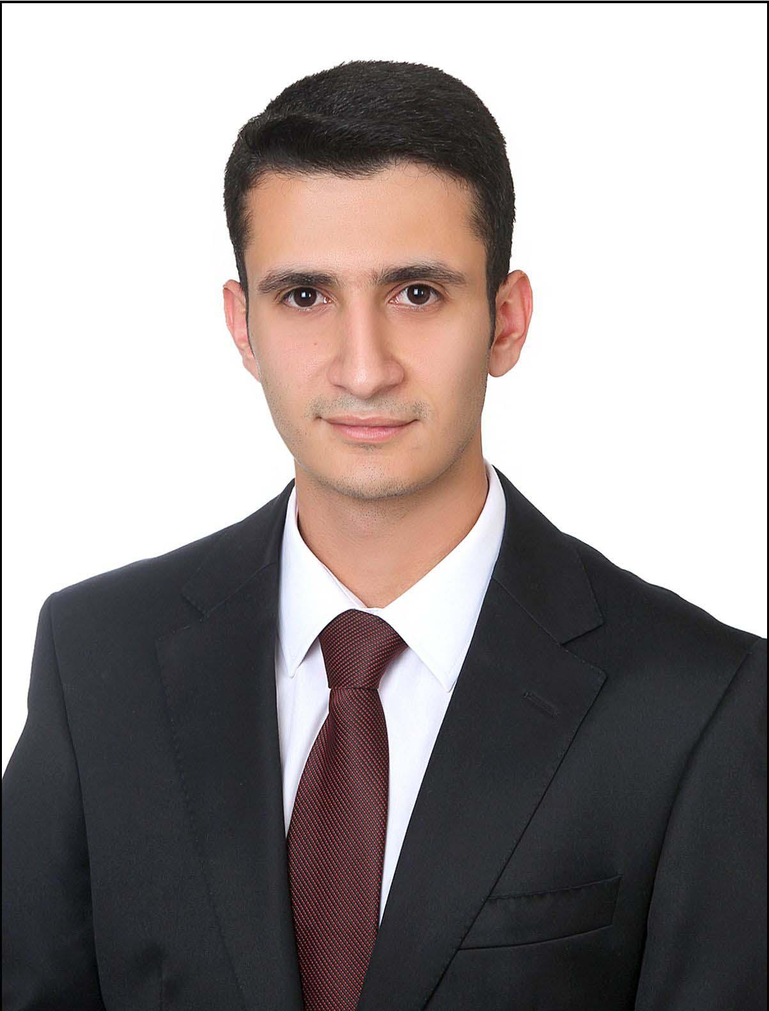
NURULLAH CILDAG
Powercoders Participant
Im Platz 24, 8330 Pfäffikon ZH
nurullah.cildag@powercoders.org | +41 76 735 79 68

Github | Learning Blog | Linkedin

Languages: German (C1-Goethe), English (B1), Turkish (mother tongue)

IT skills: ★☆☆☆☆ Python-AWS ★★★★☆ CSS3
★★☆☆☆ Jquery-DOM ★★★★★ HTML5
★★★☆☆ Javascript

WORK EXPERIENCE

03/2016 – 12/2016 HR Assistant Specialist, SOCAR Turkey, Istanbul, Turkey
- Candidate Searching in Linkedin
- Competency-based interview techniques and reporting
- Salary Ranges, Compensation Systems and Retirement Projects
- Learnt creating Organisation Charts for Group Companies by Visio
- Updating HR Policies and creating new onboarding process

EDUCATION
03/2020 – 06/2020 Powercoders – Coding Academy for Refugees, Zurich, Switzerland
- Foundations in HTML, CSS, JavaScript; specialization tracks upcoming
- Weekly business & social skills trainings (time mgt., communication, etc.)

09/2019 – 06/2020 Schnupper Programm for Asylum Seekers at University of Zurich
- Attended Micro Economy and Financial Accounting lectures, and completed German and Basics Python course

10-11/2019 Powercoders Preparation Course, Swisscom, Bern, Switzerland
- Learnt the basics of HTML,CSS3,Javascript
03/2019 ITClub Oberland Web Development Course, Volketswil, Switzerland
- HTML,CSS, Javascript, Jquery and Introduction to OOP
01-12/2018 Various Online Courses, University of Michigan, Coursera
- Introduction to HTML, CSS3, Javascript
09/2010 – 09/2014 B.A Public Economy, University of Marmara, Istanbul, Turkey
- Purchasing Intern, Albayrak Holding, 2010-2012

EXTRACURRICULAR ACTIVITIES
09/2018 – 03/2020 JA Team Leader, Foundation SERA, Zurich, Switzerland
- Organize camps for youth twice a year
- Periodically organize youth meetings and activities

